Report Core PL/SQL

by Aliaksandr Labayeu

# Tables + sequences

The basis of implementing task are tables “product category” and “product subcategory”

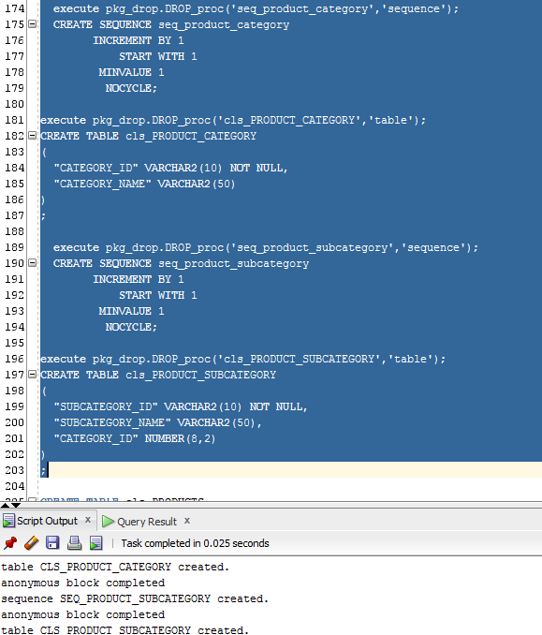

# Implementing cursors

## Implicit Cursor

Implicit Cursors should not be declared, Oracle does it on his own when we use for-loop statements:

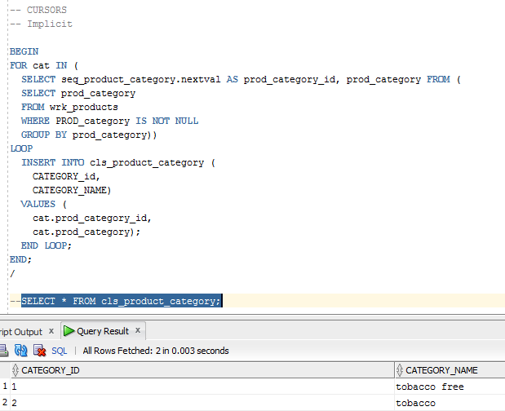

## Explicit Cursor

Explicit Cursor should be declared:

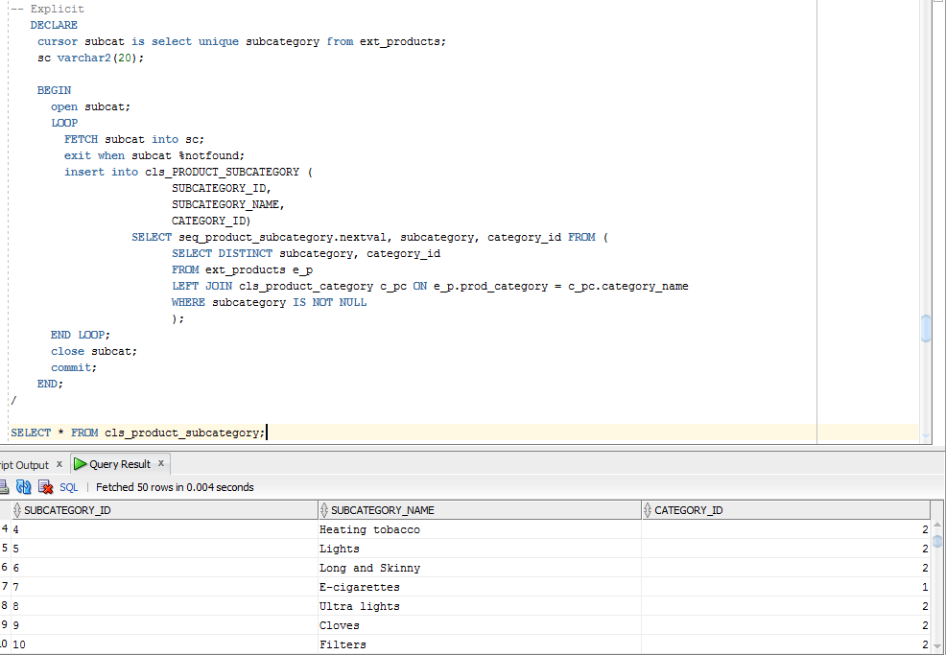

* It should be said that both cursors can’t be correctly implemented more than one time. It is so because of the not finished thoughts about organization about updating and inserting data

One of the examples of inserting NEW data in the table is to

1. Count number of rows which are not in the target table with the help of MINUS:

SELECT DISTINCT SUBCATEGORY FROM ext_products

MINUS

SELECT DISTINCT SUBCATEGORY_NAME FROM cls_product_subcategory;

1. INSERT value from only RIGHT JOINED table:

SELECT DISTINCT subcategory, category_id

FROM ext_products e_p

RIGHT JOIN cls_product_category c_pc ON e_p.prod_category = c_pc.category_name

WHERE subcategory IS NOT NULL AND c_pc.category_name IS NULL

**Merge statements**

Merge statements will be used in every layer like this:

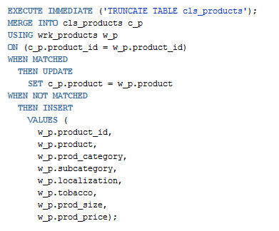

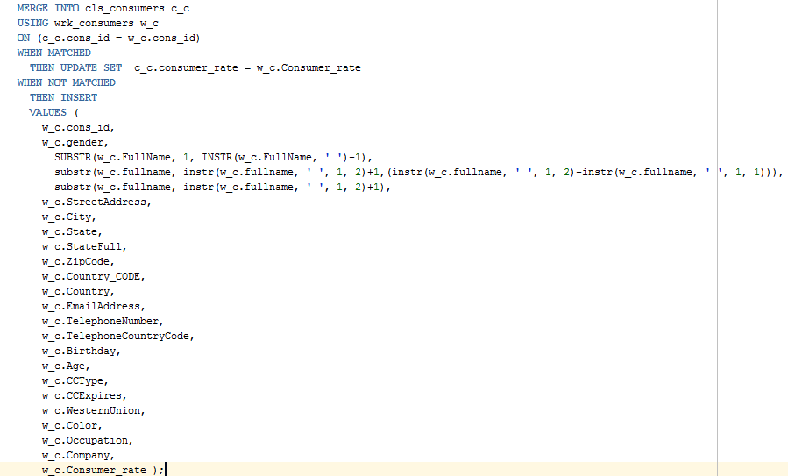

Merge statements play an extremely important role in moving data from one layer to another because it helps to insert/update/delete data within one statement, like it is shown on the screenshots above.